ENDURA | DECOMMISSIONING LUCINDA JETTY REMEDIATION — ACCESS METHODOLOGY OPTIONS ASSESSMENT

Options Assessment  Lucinda Jetty Remediation: Access Methodology  From liability to closure. | 

Project | Lucinda Jetty Remediation, Lucinda, Queensland
Client | Sugar Terminals Limited
Prepared by | Endura Decommissioning
Document No. | ED-018-2026-02
Date | 26 August 2026
Revision | B, Issued for Client Review
Engagement | Stage 1 study deliverable under accepted proposal ED-018-2026-01
Companion document | Access Options Model ED-018-2026-06 Rev B, issued with this report
Classification | Commercial in confidence

Document control
Rev | Description | By | Check | Approved | Date
A | Issued for Client Review | SK | JVI | JVI | 21/08/2026
B | Issued for Client Review. Marine base arrangements, connection and structural verification, and the proving trial added; restructured as a standalone document. | SK | JVI | JVI | 26/08/2026

Distribution
Name | Organisation | Purpose
Tim Coltzau | Sugar Terminals Limited | Review and decision
STL board and advisers | Sugar Terminals Limited | Via T Coltzau
Jed van Iersel | Endura Decommissioning | Document owner

Executive summary
The assessment in five figures
Rate the deadline requires | rate being delivered | 4.5 bents a week | well under 1
Recommended access provision (day shift, 8 fronts) | $16.04M, against $9.24M already allowed for scaffold access
Modelled completion | 11 October 2028, three weeks before the cyclone closure
True net cost of the marine base, productivity counted | $2.1M to $2.8M
Decision needed within weeks | Proving trial instruction, $350,000 to $600,000

Sugar Terminals Limited engaged Endura Decommissioning to assess how site access is provided to the Lucinda jetty remediation, and to recommend the access method that gives the works a credible path to completion by the end of 2028. This report is that assessment. It does not change what is built, welded, blasted or coated, or who does it; it changes how crews and equipment reach the work and move to the next bent.
The remediation must clear 227 priority bents within the 2027 and 2028 working seasons, which requires 4.5 completed bents a week. The works are currently delivering well under one bent a week. The gap is not workmanship; it is the access method. Scaffold is erected, encapsulated, dismantled and rebuilt at every bent, taking a 15 to 16 working day cycle of which only about half is trade work, and the site has sustained four to five scaffold crews at a time. On that arithmetic the remaining scope runs years past the deadline whoever holds the tools.
The recommended method removes that constraint. Work platforms are floated to each bent on pontoons, lifted clear of the tide on four synchronised electric chain blocks, enclosed for containment, and moved on when the bent is complete, so the access is built once and reused 227 times. A floating marine base, a small jack up barge, serves the platforms with power, air, stores, welfare and materials so the single lane roadway stays clear. The trade work on the platform is unchanged and continues at the existing contract rates. In the recommended day shift configuration the campaign runs eight work fronts, completes in October 2028, and the access provision is $16.04M against the $9.24M the current schedule already allows for scaffold access: about $6.8M more to convert a job that does not finish into one that finishes inside the deadline. A defined optimisation path, principally the choice of marine base and its wet season arrangements, brings the provision toward about $11.3M as quotations firm.
Two working patterns are presented. The day shift configuration is the base case and reflects STL’s stated preference. An extended hours configuration, with trades continuing on the secured platforms after the marine work stops at dusk, would reduce the fleet to five or six fronts and the provision to about $13.9M to $14.2M; it adds value if the working hours approvals can be obtained, and the approvals position is a decision gate, not an assumption. The marine base is likewise presented as a choice, priced with the barge for the whole campaign, with it serving only the exposed outer zone in the first season, on a cheaper moored barge, and with no base at all; the differences in cost, fleet and finish date are set out so the arrangement can be selected on evidence.
Three decisions are sought from STL to hold the programme: agreement of a pre approved repair detail library with the Superintendent, which removes a standing engineering hold from every bent; instruction of a paid proving trial on the first bents in September and October 2026, priced at $350,000 to $600,000, which measures the real cycle times before any fleet commitment; and selection of the preferred marine base arrangement so supplier quotations can be finalised. The trial is the gate: nothing beyond it is committed until its measurements are in.
Contents
Section | Page
1. Introduction and basis | 4
2. The site and its constraints | 4
3. The current access method and its limits | 4
4. Access options considered | 5
5. The recommended access system | 6
6. Working patterns: day shift and extended hours | 7
7. Programme | 8
8. Access cost | 9
9. The marine base: arrangements, productivity and cost | 10
10. Connection to the structure and structural verification | 11
11. Risk summary and hold points | 14
12. Decisions sought from STL | 15
13. Delivery and next steps | 16
Client review and acceptance | 23
Appendix A. Calculations | 24
Appendix B. Technical plates | 25
Appendix C. Supplier connection evidence and sample lift plan | 0
Appendix D. Proving trial instruction | 28

Reference conventions
Progress is measured throughout in completed, quality closed bents per week. Costs are AUD, August 2026, at concept stage screening accuracy with 25 percent contingency. Every cost, cycle and fleet figure in this report is computed in the companion model and reconciles to it to the dollar.

Introduction and basis
The Lucinda jetty carries the world’s longest sugar loading conveyor on about 5.7 kilometres of steel pilebents, and a structural remediation of those bents is under way with a completion requirement of end 2028. Endura Decommissioning was engaged under proposal ED-018-2026-01 to assess the access methodology, the means by which crews, plant and containment reach each bent, because access, not trade capacity, is governing the rate of delivery. This report identifies the options, recommends a method, prices its provision, and sets out the verification and decisions that let STL adopt it with confidence.
The assessment is built from the contract scope and specification with its drawings and priced schedule, site records made available by STL, an independent marine operability review, and written quotations and technical submissions obtained for this study from marine contractors, an access platform supplier and the coating system supplier. The quotations are held on file and are available to STL on request. Two limitations are stated. The equipment basis rests principally on one access supplier, and market soundings with comparators are programmed before any delivery model is locked; and several physical inputs, the tidal datum, the bathymetry along the alignment and the weather availability percentages, are carried on operator judgement pending survey and metocean confirmation, and are flagged wherever they are used. Every figure in this report reconciles to the companion model to the dollar.

The site and its constraints
The jetty is a repeating structure: a welded steel box headstock about 7.9 metres long and 900 millimetres deep on two raked piles of 850 and 920 millimetres diameter, with the deck at RL 8.000 carrying a single lane 8 tonne roadway and the sheeted conveyor gallery above. The tidal range is about 3.96 metres. The cyclone season runs 1 November to 30 April, leaving two 26 week working seasons in 2027 and 2028, about 50 available weeks once shipping is allowed for. The terminal takes 11 to 15 ship calls a year with the berth kept available on short notice, there is no power on the jetty, the surrounding waters are marine park, and the steel is corroded, so any load hung from the structure requires a certified and proof tested load path.
Working hours sit inside the contract’s stated construction noise limits, which apply in time bands through the day, evening and night; on the contract as read for this study the evening band to 2200 carries the same limit as the working day, with a tighter limit overnight, and this reading is to be confirmed with STL and the administering authority before any extended hours pattern is adopted. The contract contemplates night working subject to supervision and approvals, so the question for extended hours is one of environmental approvals and site governance, resolved at the hold points in Section 11.
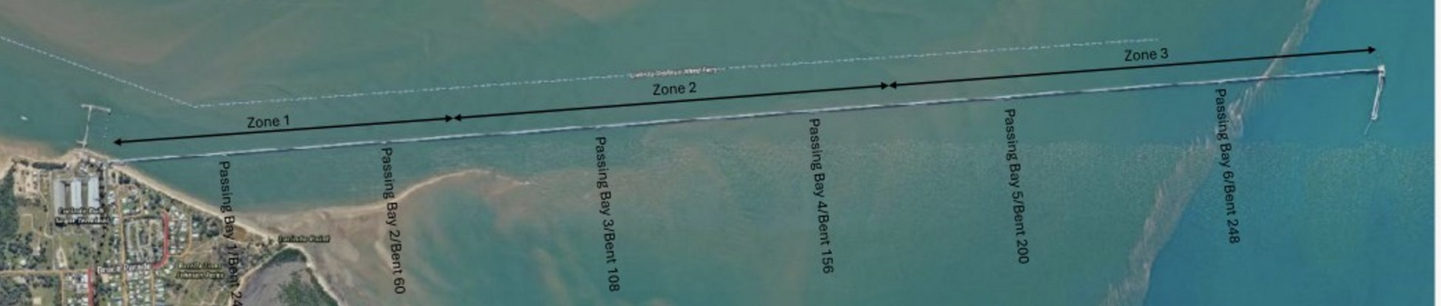
Figure 1. The jetty and its exposure zones. Zone 3 at the wharf head is open water and is worked first; the campaign finishes in the shelter of Zone 1.

The current access method and its limits
The current sequence at each bent: scaffold is hung from the kerb and the bent fully encapsulated from the roadway; the old wrapping is stripped and the steel washed, inspected and tested; weld repairs are submitted and held for engineering approval with the scaffold standing; welding, blasting and coating follow; pile jackets are fitted in tidal windows; and the scaffold is then dismantled and rebuilt at the next bent.
The constraint is built into that sequence. Of a 15 to 16 working day bent, about seven days are trade work; the balance is scaffold handling, the approval hold and calendar. Site records made available for this study show output well below one bent a week against a contract programme intent of 2.0 to 2.5, and the deadline needs 4.5. The site has run four to five scaffold crews; adding more runs into the same shared constraints, single welding and blasting spiders and a single lane roadway that every scaffold movement must use inside its timed windows, so in practice the method holds near five fronts. Even five uninterrupted scaffold fronts deliver only 1.3 to 1.7 bents a week on that cycle, which is five or more further seasons of work. Reaching 4.5 a week on the scaffold cycle would take 14 to 18 simultaneous fronts, which the structure and roadway cannot host. The finding is about the method, not any party: rebuilding the access at every bent caps the rate, and retendering the same method transfers the same arithmetic to the next contractor.
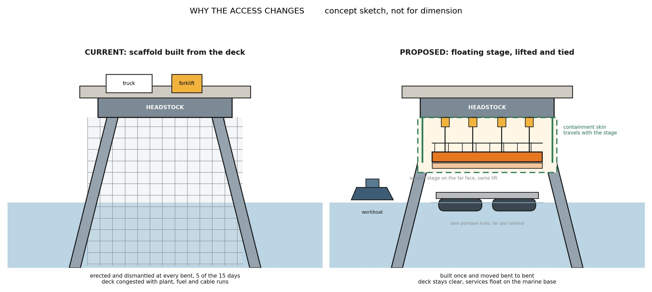
Figure 2. Comparison of the scaffold and marine access sequences: scaffold erected and dismantled at every bent, against a stage built once, lifted on chain blocks and moved from bent to bent. Concept sketch, not for dimension.

Access options considered
Six access methods were screened against the criteria that decide this job: production rate, tide independence, containment, roadway impact, structural loading, cyclone response, safety in design, approvals exposure and reuse. The screening matrix with scoring notes is held in the project record.
Method | Screening outcome | Disposition
Scaffold, current | Meets containment; pays the access cost at every bent; holds near five fronts in practice | Retained as baseline
Jack up barge as a roving work platform | Hours per relocation after jacking cycles; one location serves about two bents; draft and seabed unproven | Rejected as work platform; retained as static marine base
Floating modular pontoon spread | Tide following and relocatable; sea state limited for fine work over open water | Carried into the recommended system as the flotation element
Floating winched stages | Relocatable, tide independent once lifted, containment travels with the stage, low roadway demand | Recommended for typical bents
Suspended fixed pods | Strong operability; less relocatable along 5.7 km; higher fabrication content | Reserve configuration
Marine rope access | No encapsulated blasting possible | Rejected for headstock works; retained for pile and jacket support tasks

No single method suits every bent family, so the recommendation is a hybrid: floating winched stages for the roughly 212 typical bents, conventional or re oriented access for the anchor and passing bay bents decided plate by plate against the drawings, bent specific methods for the two special bents, and the gallery wrapping as a topside stream inside conveyor outages.

The recommended access system
A work front is a scaffold stage built in two halves on modular marine pontoons. A workboat pushes the halves to the bent, a rigging crew joins them around the piles, and the stage lifts clear of the tidal zone on four 2 tonne electric chain blocks run through a control panel to a wireless pendant. The blocks jog individually to take even tension, then lift together as a synchronised multiple hoisting operation under the Australian standard, third party certified for man riding. At working height the stage transfers onto positive ties to the structure, the blocks move ahead to the next bent, and crews step on from the deck. Crews are off the stage for every lift and a dedicated rescue craft is on the water whenever crews work over it. Two stages hang on the long faces of the headstock, giving access right around each pile with about 2.2 metres of working clearance each face. The access supplier holds five platforms of this system today; where additional platforms are needed, conventional scaffold stages can be built onto marine grade pontoons to the same arrangement, so the method is not captive to any single supplier’s fleet and platform sizes can be customised where the structure demands it.
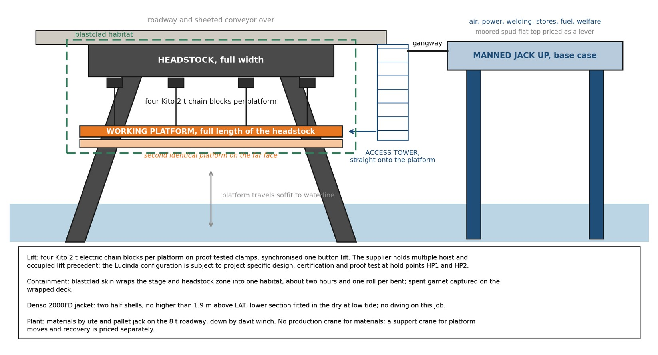
Figure 3. One work front: the floating stages, the chain block lifting system, the containment skin, the jacket band and the materials path. Concept sketch, not for dimension.
Containment travels with the stage: sheeting over the stage and headstock zone turns the work face into one enclosed habitat, about two hours and one roll per bent, with spent abrasive and debris landing on the wrapped deck for recovery. The pile jacket is fitted as two half shells within the band the coating specification defines, with the lower section placed in the dry at low tide, so no diving is carried in the base case.
Behind the fronts runs one marine production system: a small manned jack up barge as the static base, the floating stages, a workboat and a shared support crane. The base hosts compressed air and welding power reticulated to the fronts, breathing air, coating stores held at temperature, fuel, water and waste handling, spares, and crib, washrooms and drying space at deck level, all afloat and off the 8 tonne roadway. Crews travel the jetty by vehicle at shift start and step down to the stages; through the shift the base is a gangway from the work face. Section 9 quantifies what that arrangement is worth and prices the alternatives to it.
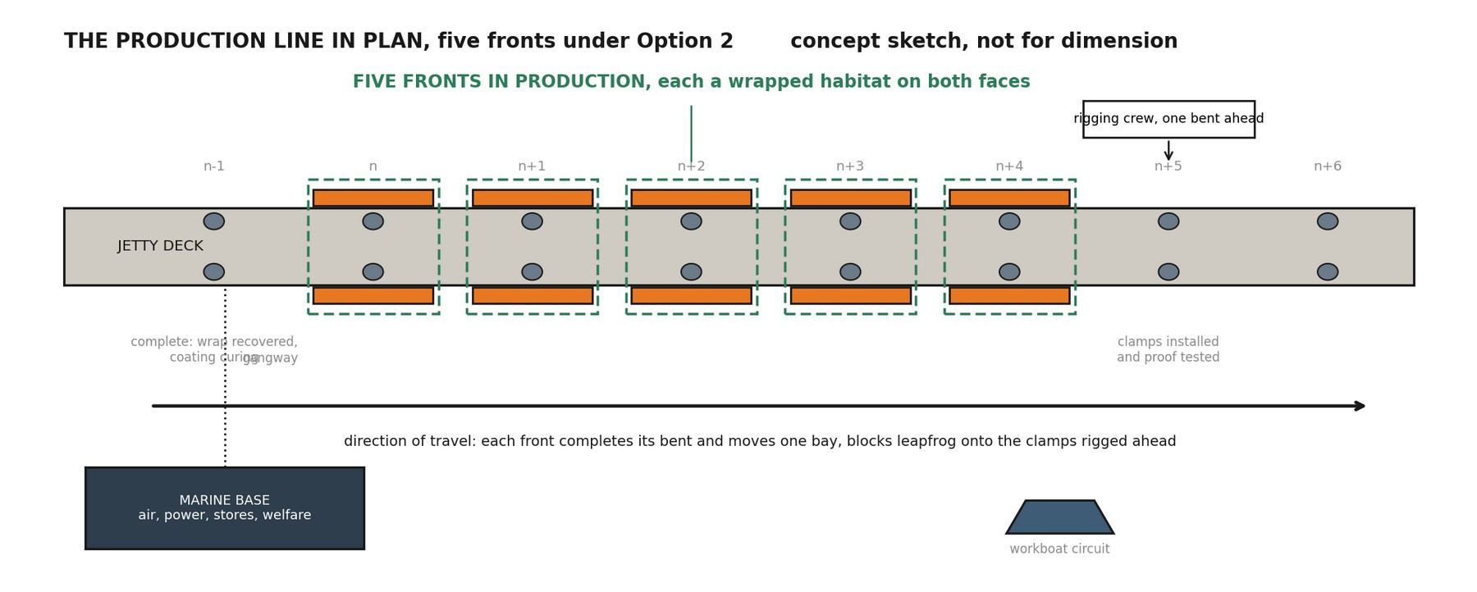
Figure 4. Production line arrangement in plan: fronts in work, the rigging crew one bent ahead, the completed bent curing behind, the marine base serving the fleet. Concept sketch, not for dimension.

Working patterns: day shift and extended hours
Both patterns use the identical access system, trade content and rates; they differ only in when the trades work. A note on the cycle used throughout: with the repair detail library of Section 12 agreed, each bent takes nine working shifts, seven of trade work and two of marine moves. Weather then stretches those shifts across the calendar: marine moves are carried at 80 percent availability and work on the secured platform at 90 percent, the upper band of the marine operability review, with lower bands carried as sensitivity.

Day shift, the base case
All work runs in a six day, single shift week. Two move shifts at 80 percent availability take 2.5 calendar days, and seven trade shifts at 90 percent take 7.8, so a bent takes about 10.3 calendar days from arrival to departure. Working six days a week, one front therefore completes 6 over 10.3, about 0.58 bents a week. Meeting the required 4.5 a week takes eight fronts, which together deliver about 4.7; at the mid availability band it takes nine. This is the recommended configuration and reflects STL’s stated preference for daylight working.

Extended hours, held open for value
Every marine activity stays in daylight. Once a platform is lifted, tied and secured it is a fixed suspended work place accessed from the deck, and trade work can continue on it after dark inside the lit, enclosed habitat. Worked as two trade shifts per calendar day the bent cycle falls to about 6.4 days, each front delivers 0.94 a week, and five fronts carry the campaign. A middle pattern holds both trade shifts inside 0600 to 2200, six fronts, so the overnight band is never entered. All patterns carry the same site controls, standby cover for any work over water after dusk, task lighting, spill response and marine fauna observation; what changes between them is the scale of the working hours approval, from none beyond current arrangements for day shift, to an evening extension, to full night working. Extended hours add value if those approvals are obtained; the written approvals position is a decision gate at Section 12, not an assumption of this report, and the recommendation does not depend on it.
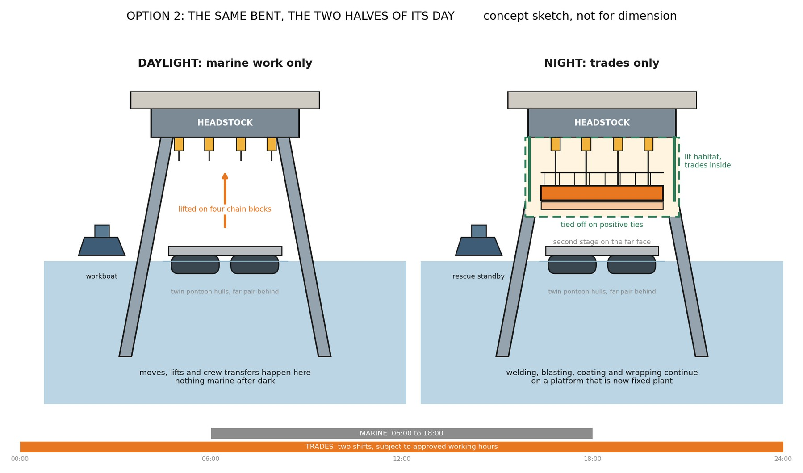
Figure 5. Extended hours at a single bent: marine operations in daylight, trades continuing on a platform tied off as fixed plant. Concept sketch, not for dimension.
Weather availability scenario (moves / platform work) | Day shift fronts | Extended hours fronts | 0600 to 2200 pattern fronts
Upper band, carried (80% / 90%) | 8 | 5 | 6
Mid band (70% / 85%) | 9 | 6 | 7
Lower band (60% / 80%) | 10 | 6 | 7
Repair detail library not agreed | 11 | 8 | 8

The repair detail library in the last row matters more than the weather. Today each bent’s weld repairs are submitted and held for engineering approval, a hold of about three days per bent in the current sequence as reported from site, to be confirmed with the Superintendent. A pre approved library of standard repair details, agreed once, lets routine repairs proceed on inspection, removes that hold from every bent, and is the single largest productivity decision available to STL at no plant cost. The cycle above assumes it is agreed; without it the day shift fleet grows to eleven fronts.

Programme
The campaign runs in five phases. First, a paid proving trial on the supplier’s five existing platforms in September and October 2026, clear of the cyclone closure: real bents, real lifts, measured cycle times, at $350,000 to $600,000. Second, tender and award through the 2026 to 2027 wet season, so no working time is spent on procurement. Third, fabrication of the platform fleet balance, mobilisation, assembly and proof loading through March and April 2027, with cyclone readiness triggers in place. Fourth, working season one from May to October 2027, starting at the exposed wharf head in Zone 3 and working shoreward, about 118 bents. After the wet season lay up, season two from May 2028 completes about 109 bents in the shelter of Zones 2 and 1. At the modelled rates the priority scope completes about 11 October 2028, three weeks before the closure. The finish is a modelled outcome; a dated, bent by bent programme is a deliverable before the fleet order, and a September trial start needs the STL instruction within weeks of this issue.
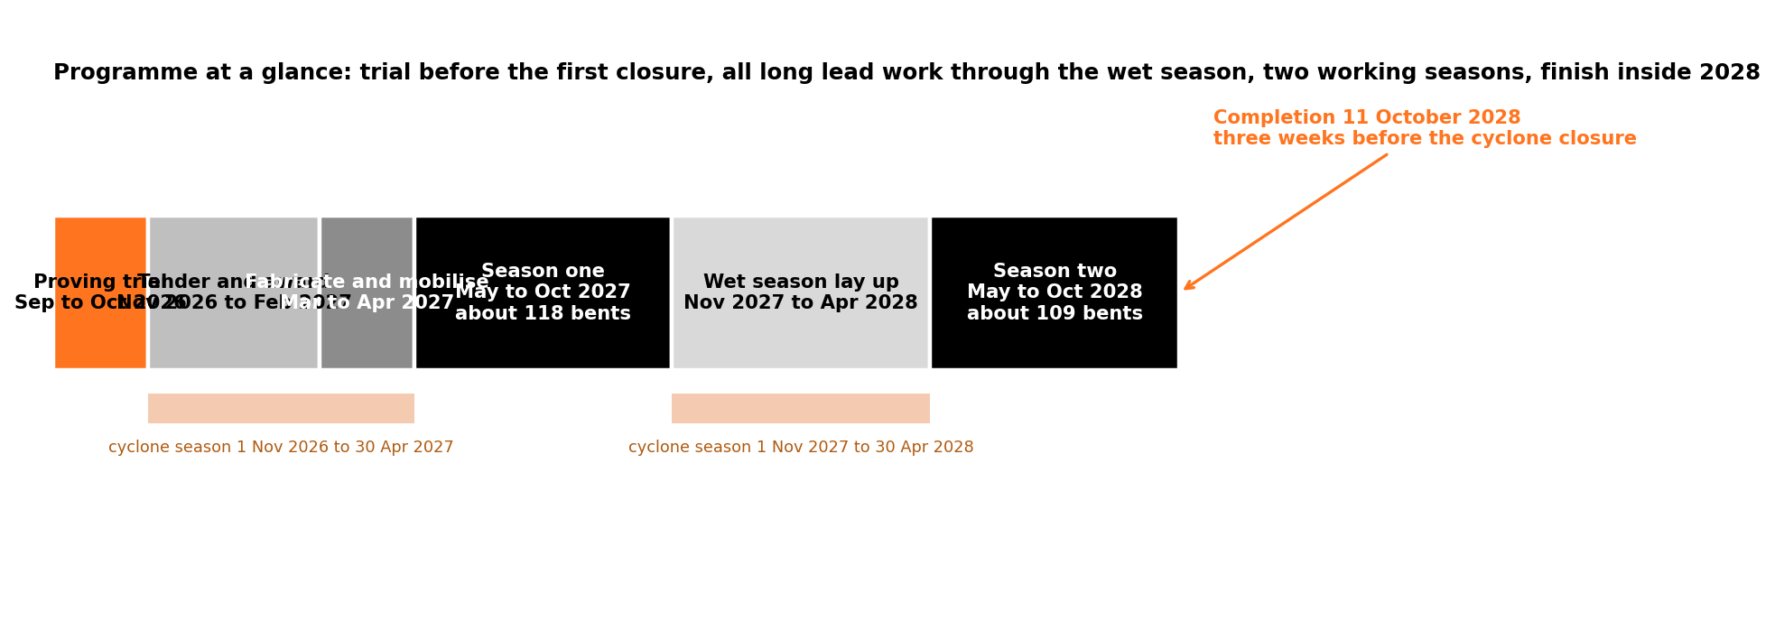
Figure 6. The programme at a glance: trial before the first closure, procurement and fabrication through the wet season, two working seasons, completion inside 2028.
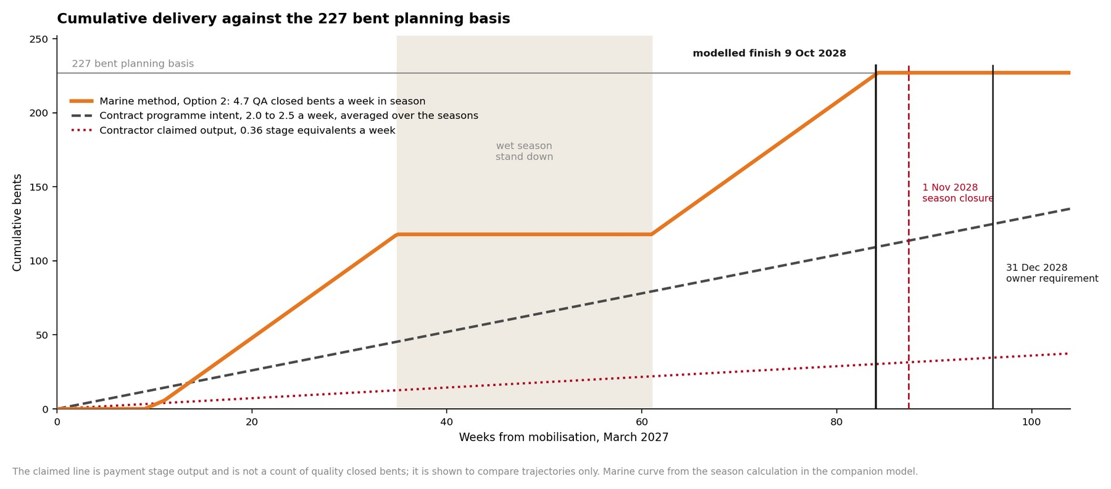
Figure 7. What the rate change means: cumulative bents completed under the recommended method against the current trajectory and the 227 bent requirement.
Three programme risks rank ahead of the weather: the platform fabrication lead time into March 2027, the environmental and marine approvals pathway, and the priority scope count itself, which spans 227 to 257 on the current register pending the extract sought at Section 12. Shipping calls concentrate July to December, so season one work at the wharf head is planned around berth exclusion windows; the shipping allowance carried in the available weeks is tested against the shipping programme before the fleet order.

Access cost
The costs below are the access provision only, at concept stage screening accuracy with 25 percent contingency, in August 2026 dollars. They exclude the platform fleet build or hire beyond the five existing platforms, marine insurances and permits, port charges, accommodation and escalation, each identified for pricing at the next stage. Trade labour, materials and consumables are unchanged from the current arrangements and are excluded by scope definition. Rates are taken from the contract’s priced schedule where the contract carries the role, and otherwise from written quotations obtained for this study from marine and access contractors; the quotations are held on file and available on request. The current method comparator is derived, not assumed: the priced schedule allows about $29,000 to $30,000 of access at each typical bent, and the safe access items across all bent families total $9.24M.
Access cost build ($M, incl 25% contingency in the total) | Day shift, 8 fronts | Extended hours, 5 fronts | 0600 to 2200, 6 fronts
Access kit: winches, pontoons, platform modules | 2.23 | 1.43 | 1.72
Marine base, operating | 3.40 | 3.38 | 3.25
Access crew over the campaign | 4.72 | 4.08 | 4.62
Fixed items: certification, mobilisation, wet season lay up, first bent proving, demobilisation | 2.48 | 2.48 | 2.48
Contingency at 25 percent | 3.21 | 2.84 | 3.02
Access provision total ($M) | 16.04 | 14.22 | 13.95
Per bent ($) | 70,647 | 62,623 | 61,500

The comparison that matters: $16.04M of access that delivers 4.5 or more bents a week and finishes in 2028, against $9.24M of scaffold access already in the schedule that is delivering well under one and does not finish. The difference, about $6.8M, buys the outcome. Section 9 shows how the largest line, the marine base, can be bought several ways, and Section 8’s optimisation path in the companion model brings the day shift provision toward about $11.3M as the base and wet season quotations firm.

The marine base: arrangements, productivity and cost
The marine base is the floating services hub of the system and the largest single line in the estimate, about $4.3M over the campaign before contingency. Because it is large, this section prices the campaign with the base, without it, and with it deployed in different ways, each arrangement carrying its own productivity assumption beside its cost so the choice can be made on evidence.
What the base does for a working day is practical. Without it, every crib break, washroom trip, consumable top up and stores run is a return journey along up to 5.7 kilometres of single lane roadway inside its timed passing windows, about 12 minutes each way, roughly an hour of lost working time per 10 hour shift. With the base those needs are a gangway from the work face. The recovered time only helps where the work is paced by crew hours at the face, welding, blasting, coating and wrapping; it does not shorten coating cure, tidal windows or approvals. Priced conservatively, the base is worth about half a shift to a full shift per bent, and the table carries both the plain basis, seven trade shifts per bent in every arrangement, and the serviced basis of six and a half.
Arrangement | What it means in plain terms | Trade shifts per bent | Fronts | Access cost ($M) | Modelled finish
No marine base | All services from the wharf and shore laydown; crews travel the roadway for every need; a ninth front covers the lost time | 7.0 | 9 | 12.49 | late Sep 2028
Jack up barge, whole campaign | The base serves the fleet for both seasons; the carried, conservative case | 7.0 | 8 | 16.04 | 11 Oct 2028
Jack up barge, whole campaign, serviced productivity | As above, with the half to one shift per bent the base returns priced in | 6.5 | 8 | 15.34 | 17 Sep 2028
Barge in Zone 3 only, season one | The base holds the exposed wharf head water in season one, where deeper draft demands it, then demobilises; season two runs shore serviced in the shelter | 7.0 | 8 | 14.68 | 23 Oct 2028
Zone 3 season one on a moored spud | As above with a cheaper moored flat top barge in place of the jack up for season one | 7.0 | 8 | 13.08 | 23 Oct 2028
Moored spud, whole campaign | A moored flat top carries the same services for both seasons at a lower day rate; boarding in rough weather is the trade off | 7.0 | 8 | 12.26 | 11 Oct 2028

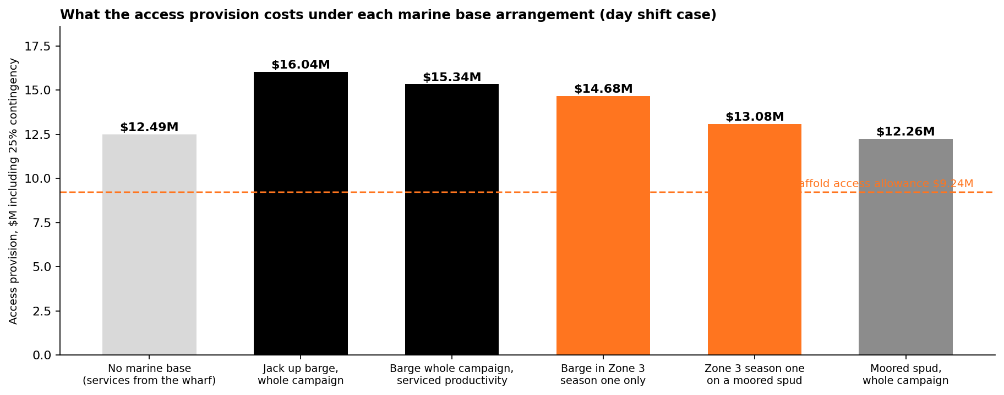
Figure 8. Access provision under each marine base arrangement, day shift case, against the current scaffold access allowance.
Read plainly: doing without the base saves about $3.55M on paper but costs a ninth front and an hour of every shift, so once the base’s productivity is priced its real net cost is between about $2.1M and $2.8M, and the campaign keeps a weather refuge, faster cyclone response and a clear roadway. The zone phased arrangements are method first and saving second: the jack up needs more than 4 metres of water, which the outer zone has and the inshore shelter does not, so serving season one from the barge and season two from the shore follows the geography. The barge day rate itself is the largest open number, with written quotations spanning a wide range, and the reconciliation letter issued for this study closes it before the options workshop; every figure above carries the highest quoted rate until it does. Two further arrangements, a dry hired deck and a wharf based service train, are priced once STL confirms the marine crewing position and the laydown and power points. As a downside check, if working from the platforms proved a full shift per bent slower than scaffold instead of faster, the day shift fleet becomes nine fronts at about $16.70M and the completion date still holds in October 2028.

Connection to the structure and structural verification
Every lifted platform hangs from the jetty, so the first structural question of this method is where it hangs from and how that strength is proven. This section sets out the connection concept, how the stages are secured, and the verification route: who designs, who checks, who certifies and when. The corroded headstock steel, the very member being remediated, carries nothing. Consistent with previous over water works at the terminal, which suspended equipment from the concrete above the deck, the load path here runs through the precast concrete roadway and kerb.

The connection points
The access supplier’s standard concrete connection uses screw anchors carrying forged lifting points, with socket base plates on the same anchor family where a scaffold tube interface is wanted. At each hanging point a plate carrying a group of M14 concrete screw anchors at 115 millimetre installation depth is fixed to the deck unit or kerb, and a swivel lifting point takes the chain block hook. The anchor is assessed under AS 5216 with European Technical Assessment for cracked concrete: at that embedment in 20 MPa concrete the published design resistances are 28.94 kN tension in uncracked concrete, 20.26 kN in cracked concrete and 35.15 kN in shear, set out at Plate 1 below. The lifting point is forged, rated to EN 1677-1 and AS 3776 with a 4 to 1 safety factor and the same working load limit in every direction. The anchors install without expansion, tolerate edge proximity, and back out cleanly at demobilisation leaving only patchable holes. Deck penetrations are discussed with the Superintendent before any drilling, as the specification requires.
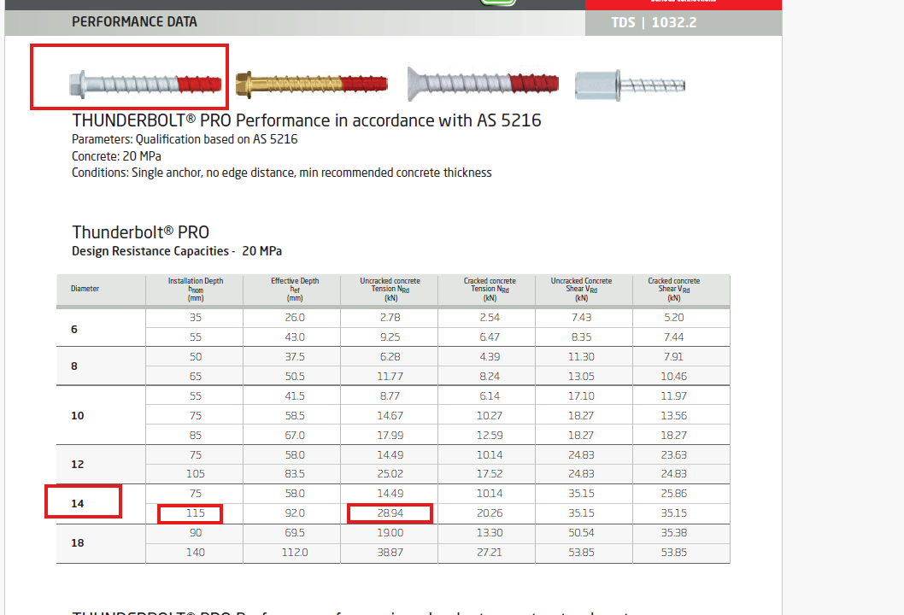
Plate 1. Supplier anchor performance data to AS 5216 at 20 MPa. The highlighted row is the arrangement carried here: M14 at 115 mm installation depth.
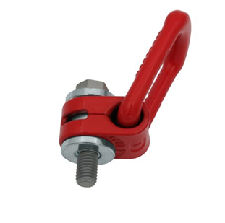  Plate 2. Forged swivel lifting point, EN 1677-1 and AS 3776, safety factor 4 to 1; the standard bolt is replaced with the screw anchor for the concrete fixing. | 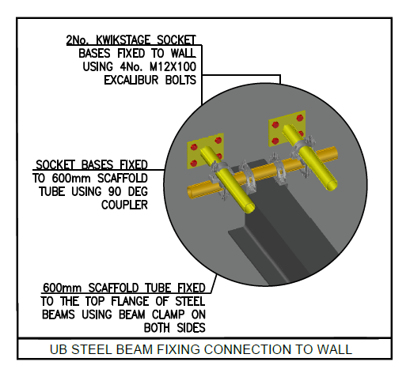  Plate 3. Supplier standard socket base detail on the same anchor family: plates on screw anchors carrying scaffold tube by coupler.

Against the demand: a four anchor group carries the full 2 tonne block rating of about 19.6 kN plus hoisting dynamics with real margin before group, edge and member reductions, and the certified precedent below shows the blocks running at under half that rating in service. Those reductions are the professional engineer’s work and are exactly what remains open: measured strength and thickness of the deck units against the original design drawings, cracked or uncracked classification near the keeper angle works, edge distances at the kerb, group spacing and cyclic loading from repeated lifts.
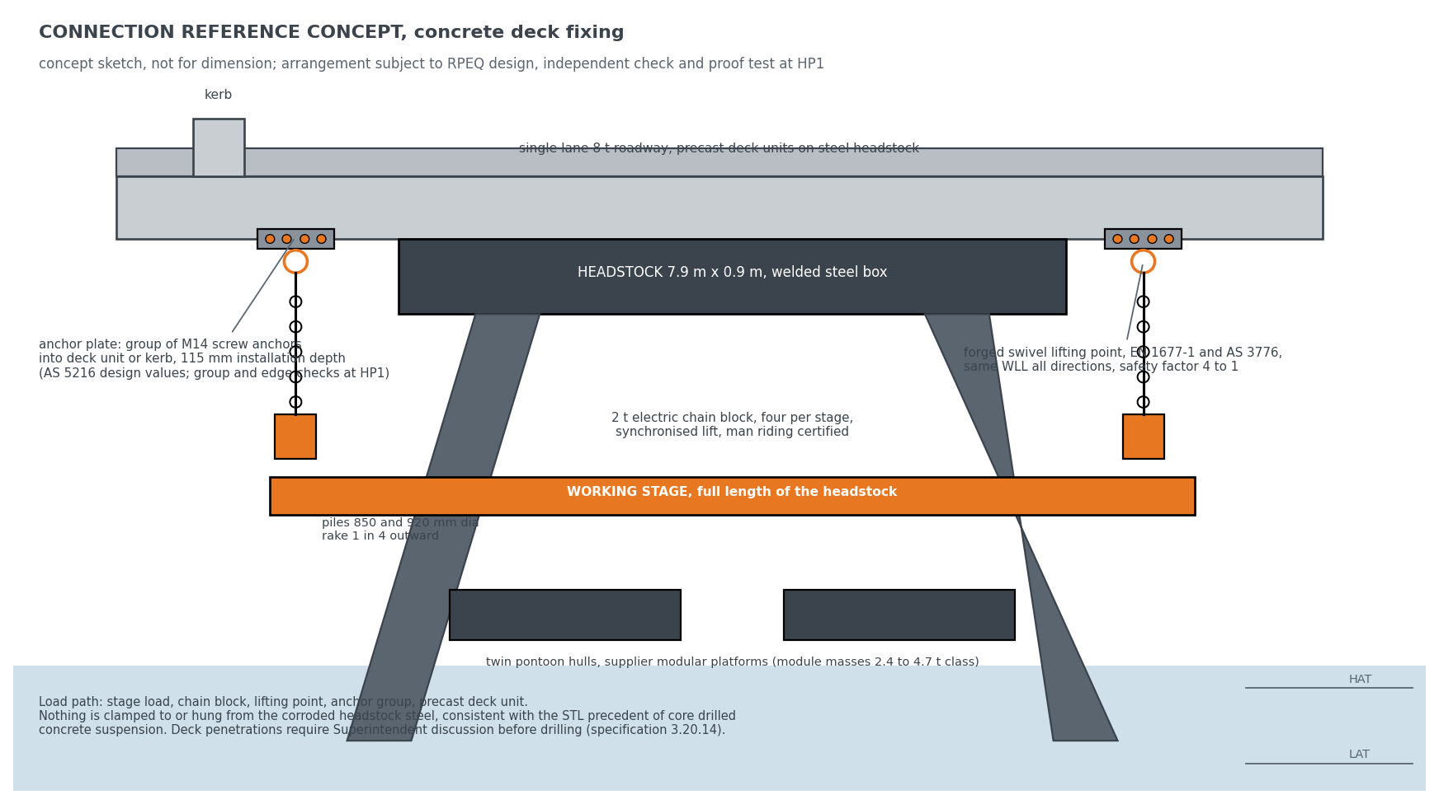
Figure 9. The connection reference concept: anchor plate groups in the concrete deck and kerb, swivel lifting points, synchronised chain blocks, nothing hung from the headstock steel. Concept sketch, not for dimension.

Securing the stage
The stage is held by layered, independent controls. Four chain blocks share the lift, each with a load holding brake, and on the certified precedent each carries less than half its rated load, so the group holds the stage with margin even with one hoist discounted. Every anchor point is installed and proof load tested one bent ahead of the work, before any load and before any person relies on it. The blocks jog individually to take even tension and then lift as one synchronised operation, so no point is shock loaded. Lifting is the exception, not the norm: at working height the stage transfers onto positive ties to the structure, the hoists come off load, and the stage is a tied, fixed platform for the days of trade work, with the chain blocks carrying load only during travel between bents. Crews are off the stage for every lift, man riding transfers run under third party certification, a rescue craft is on the water whenever crews work over it, and the pontoons remain beneath the stage through the tidal band. Every element is proven at the first bent under proof load and inspection before the method is committed. No single failure lowers a stage.

Verification route
Endura’s engagement covers methodology, programme and procurement; the design duty for the connection and temporary works sits with the supplier’s and STL’s engineers as below, and if the concept develops into connection design that is separately instructed scope. Five arrangements were considered before the concrete fixing was adopted, and where a particular deck unit or kerb fails its capacity check the reserve load path is a pile clamp onto the raked piles, decided bent by bent; the method does not assume every bent passes.
Arrangement | Assessment | Standing
Bolted clamp around the headstock | Clamps to the member being remediated; capacity rests on corroded section | Not carried
Through bolted bracket on the headstock | Drills a primary member; permanent modification of corroded steel | Not carried
Welded lug on the headstock | Hot work on corroded in service steel; permanent | Not carried
Pile clamp | Moves load to the raked piles; changes stage geometry and habitat sealing | Reserve, bent by bent
Concrete deck and kerb fixing: screw anchor groups with forged lifting points | Load path in the precast, off the corroded steel, removable, consistent with previous terminal works | Adopted as the reference concept

Verification item | Verified by | When
Anchor group capacity in the deck units: measured strength, thickness, edge distance | Registered professional engineer, with independent check | Before the trial
Synchronised four block hoisting | Supplier engineering plus third party certification | Before man riding
Man riding certification | Third party | Before the trial
Linked deck load cases: articulation, unequal loading | Registered professional engineer | Before the arrangement is fixed
Certified mass schedule: stage, containment, materials, crew | Supplier, checked by Endura | Feeds every item above
Lift plan, proof test regime, rescue arrangement | Supplier, accepted by the STL Superintendent | Before the trial

The lifting system carries direct precedent: the supplier’s certified lift plan on a comparable bridge span ran the same four block synchronised arrangement at a maximum lift of 3.802 tonnes including two scaffolders aboard, 0.951 tonnes per hoist, 48.3 percent of the working load limit, certified by a registered professional engineer, reproduced at Appendix C as the sample. Its connection was beam clamps to structural steel, which is not used here; the hoisting method transfers as it stands and the connection transfers to the concrete as above. The supplier’s Lucinda specific methodology and lift plan are in preparation and will accompany this report as an annex, carrying the certified mass schedule, the load per hanging point, the anchor layout, the proof test regime and the rescue arrangement.

Risk summary and hold points
The principal risks of adopting the method, and how the method treats each, are summarised for review. Nothing in the recommendation is committed past a hold point until its evidence exists.
Risk | How it is treated | Residual position
Safety of persons over water | Man riding certification, crews off the stage for every lift, rescue craft on the water | Managed under supplier certification and proof load
A stage falling | Four braked hoists each under half rated load, positive ties at height, proof test one bent ahead | No single failure lowers a stage
Working hours approvals | Day shift recommended and independent of them; extended hours held as value subject to approvals | Decision gate, Section 12
Weather and cyclone response | Floating fleet demobilises in hours; readiness triggers; availability carried as sensitivity | Trial measures true availability before the fleet order
Fabrication lead time | Five platforms exist; scaffold on marine pontoons is an alternative build route; balance ordered after the trial | Critical path to March 2027
Scope quantity, 227 to 257 | Register extract sought at Section 12 | Up to 13 percent on totals until confirmed
Marine base day rate spread | Quotations reconciled in writing before the workshop; the highest rate carried meanwhile | Closed before any base commitment
Trade resourcing at scale | About forty trade heads across eight fronts at contract rates, staged up through the early bents | Confirmed with the trade contractor before the fleet order

Ref | What must be proven | Cleared by
HP1 | Hanging point capacity in the concrete deck and kerb | Engineer design and independent check; proof load at the first bent
HP2 | Containment, extraction, noise and lighting performance in the field | First bents under the proving trial
HP3 | Surface preparation and coating compatibility, including waste classification | Written coating supplier position and first batch waste test
HP4 | Seabed and depth along the alignment; jack up locations need over 4 m | Chart depths from STL or an early survey
HP5 | Environmental, marine and port approvals for plant, anchoring, hours, noise and light | STL led engagement, supported by Endura
HP6 | Real weather and tide downtime for floating and fixed work | Operability model on metocean records
HP7 | Condition and true completion status of part complete bents | Close out survey before the restart sequence is set
HP8 | Market capability beyond the single supplier basis | Market soundings before the delivery model is locked

Decisions sought from STL
Commitment is staged so that approving each step never commits the next. The proving trial commits only itself; the campaign is committed only after the trial’s measurements are in.
1. Agree the pre approved repair detail library with the Superintendent, removing the standing engineering hold from every bent. The reported cycle assumes it.
2. Instruct the paid proving trial for September and October 2026, priced at Appendix D at $350,000 to $600,000; a September start needs the instruction within weeks of this issue.
3. Confirm the written position on working hours, so the extended hours value is either banked or set aside on evidence.
4. Provide chart depths along the alignment, or authorise the survey, for the marine base selection.
5. Indicate the preferred marine base arrangement from Section 9, so supplier quotations are finalised on one or two arrangements.
6. Provide the bent register extract confirming the priority scope count; 227 is carried and the current register runs to 257.

Delivery and next steps
Three procurement routes are open once the method is adopted: an instructed change within the existing arrangements, a separate access package procured by STL and made available to the trade works, or a consolidated retender on the new method. The study is neutral between them; the choice follows the trial and the market soundings, and whether the existing arrangements accommodate a change of this size is a matter for STL and its advisers. Under any route, Endura’s role is the evaluation framework, the performance specification against the reference concept, the market soundings and bid scoring alongside STL; Endura is independent of the suppliers and contractors assessed and holds no interest in any tender outcome.
The immediate next steps are the trial instruction, the marine base quotation reconciliation, the supplier’s methodology and lift plan for the Lucinda connection, and the options workshop at which the base arrangement and working pattern are selected. Appendix D carries the trial instruction ready for execution.
Client review and acceptance
This deliverable is issued to Sugar Terminals Limited for review under engagement ED-018-2026-01. Acceptance records that STL has reviewed this revision and accepts it as the basis for the decisions described in it. Acceptance does not transfer design duty for the reference concept, which remains subject to the hold points in Section 11. Comments may be returned in lieu of acceptance, in which case a revised issue follows under the revision history.
Sugar Terminals Limited | Name and position | Signature and date
Reviewed by
Accepted by
Appendix A. Calculations
Required rate: 227 bents over 50.4 available weeks, two 26 week seasons less a 1.6 week shipping allowance, gives 4.5 a week. Current method: 15 to 16 day cycle, four to five sustainable fronts, 1.3 to 1.7 a week ceiling. Marine cycle: 7 trade shifts plus 2 move shifts, plus 3 hold shifts where the repair detail library is not agreed. Day shift: 2 moves at 80 percent plus 7 trade shifts at 90 percent, 2.50 plus 7.78, about 10.3 days; 6 working days over 10.3 gives 0.58 a front week; 4.5 over 0.58 gives 8 fronts. Extended hours: trade shifts at 2 per calendar day, 2.50 plus 3.89, about 6.4 days, 0.94 a front week, 5 fronts. The 0600 to 2200 pattern: 1.6 shifts per calendar day, about 7.4 days, 0.82, 6 fronts. Serviced basis: 6.5 trade shifts per bent with the base, cycle 9.7 days, 0.62 a front week. No base: 7 shifts at 82 percent platform availability for shore servicing, cycle 11.0, 0.54, nine fronts. Adverse check: 8 shifts, cycle 11.4, 0.53, nine fronts, $16.70M, completion holds in October 2028. Cost: kit per front week plus marine base plus fleet access crew on campaign weeks plus fixed items, plus 25 percent contingency. All figures compute live in companion model ED-018-2026-06 Rev B and reconcile to the dollar.
Appendix B. Technical plates
Concept arrangements and supplier evidence, not construction drawings. Dimensions are indicative and are confirmed at the hold points.
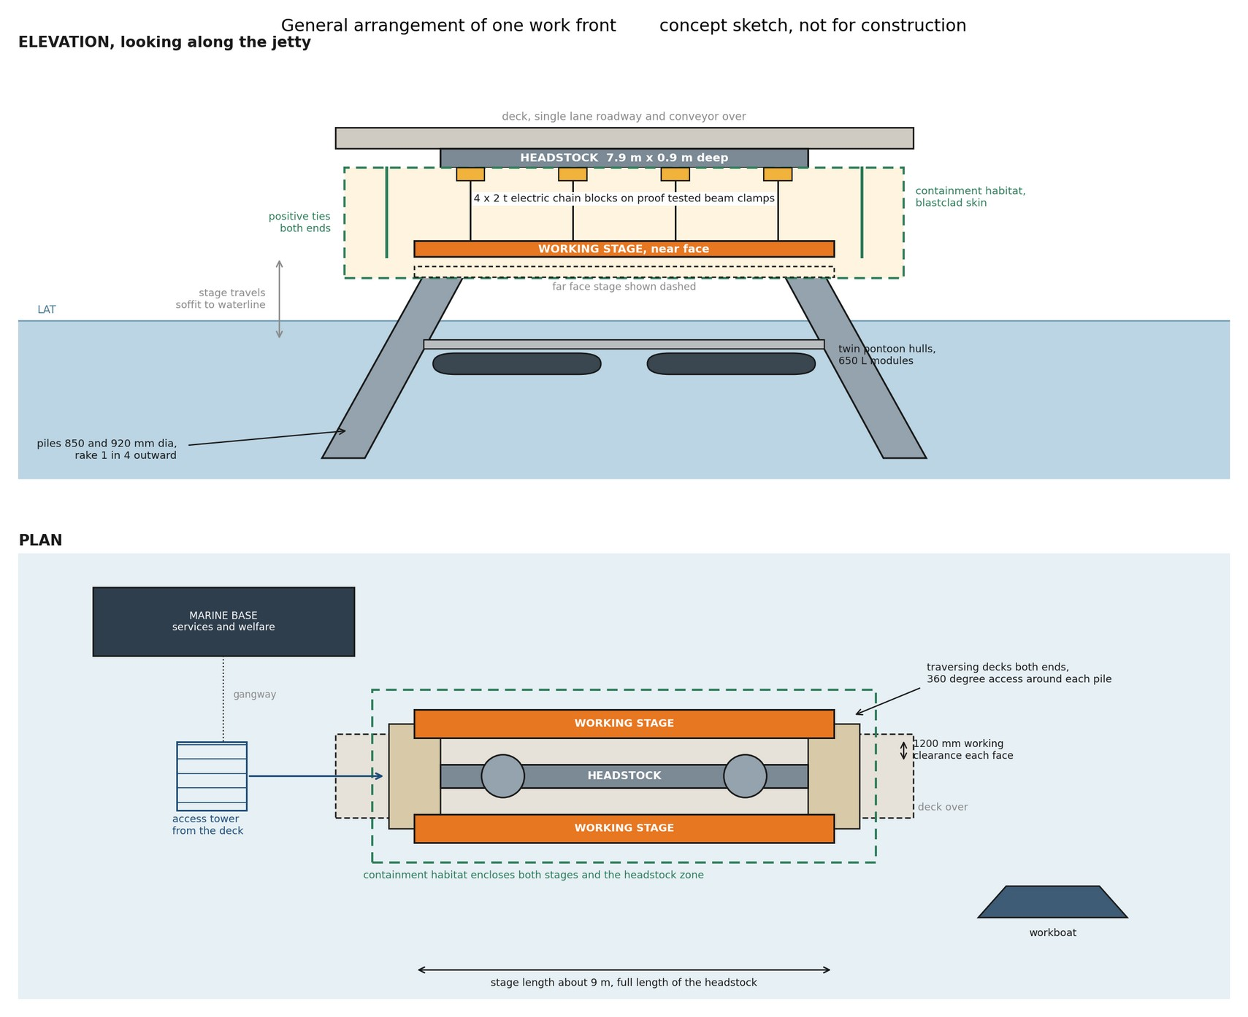
Figure 10. General arrangement of one work front, elevation and plan: two stages on the headstock long faces, four 2 t chain blocks each, traversing decks at the ends giving access around each pile. Concept sketch, not for construction.
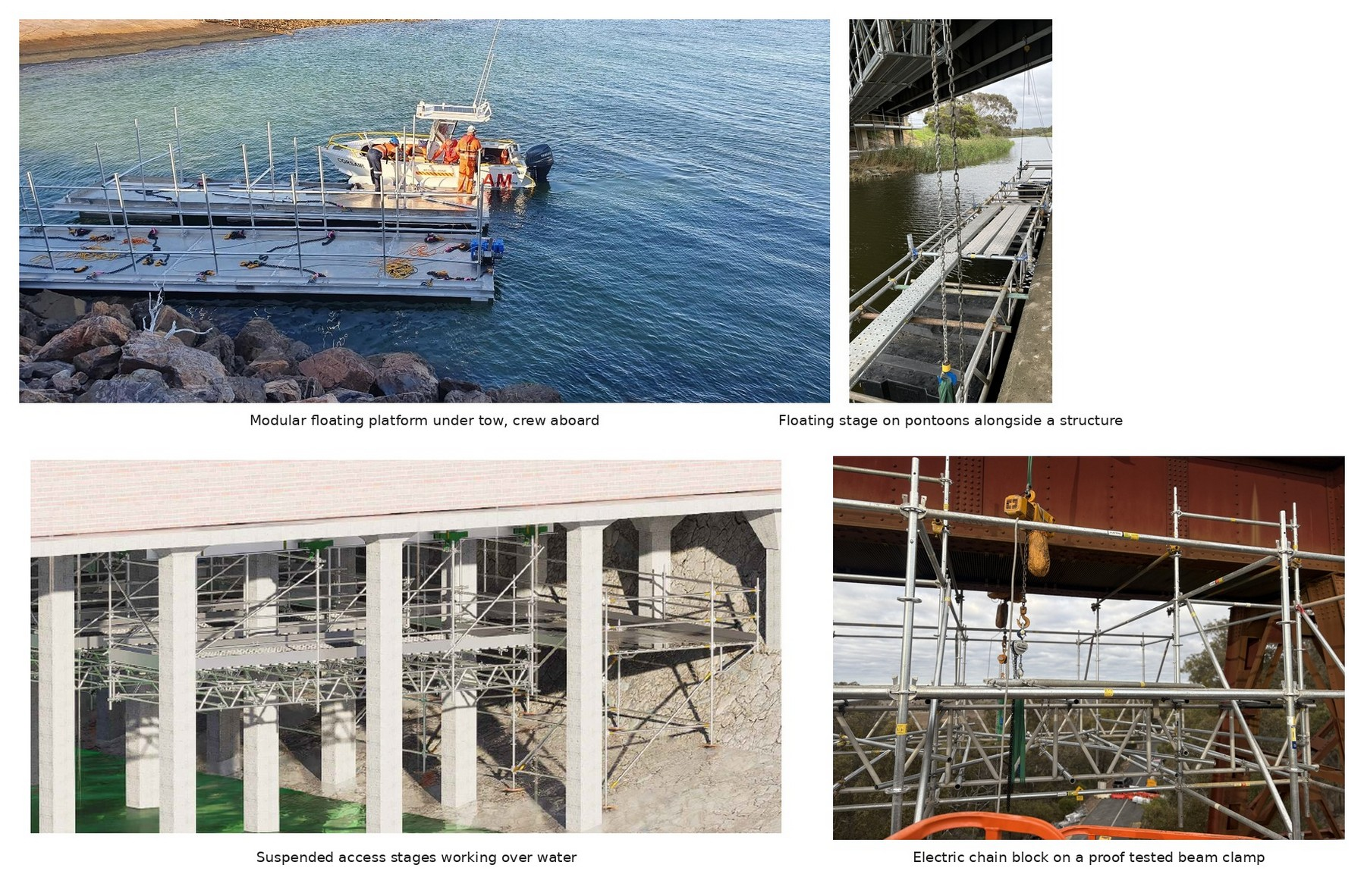
Figure 11. Supplier equipment of the type proposed, in service on other structures; the Lucinda arrangement is subject to project specific design and certification.
Appendix C. Supplier connection evidence and sample lift plan
The supplier’s in service reference and sample certified lift plan supporting Section 10. Full product data sheets accompany this issue as separate documents; the Lucinda specific methodology and lift plan follow as an annex when received.
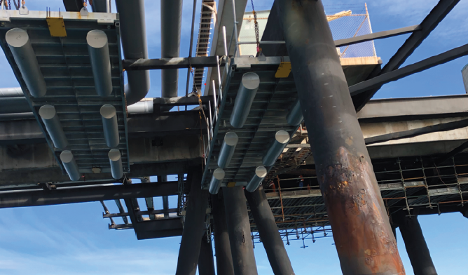
Plate 4. Supplier modular platforms suspended beneath a wharf alongside large diameter piles, in service on a comparable over water remediation.
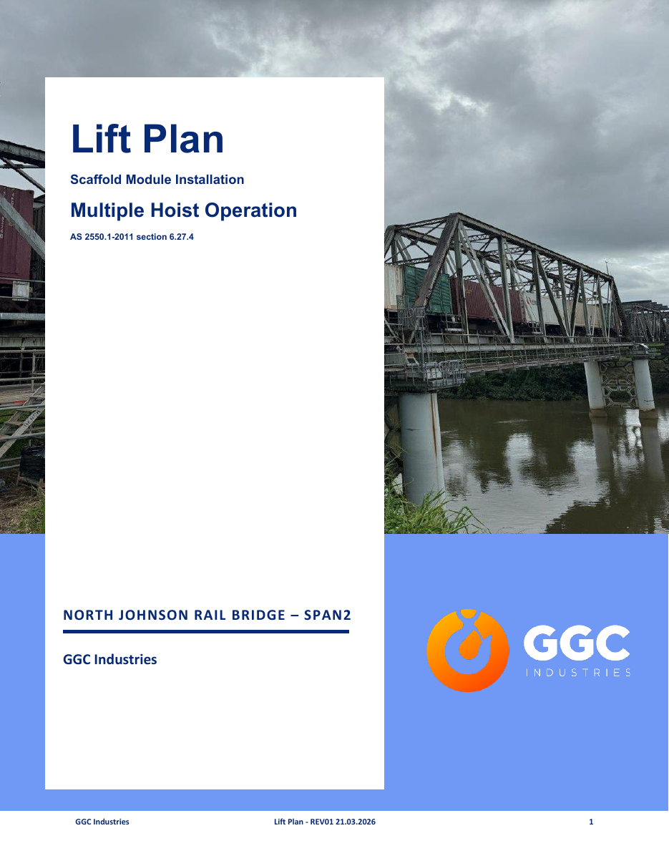
Plate 5. Sample certified lift plan cover sheet: the same four block synchronised system on a comparable span, maximum lift 3.802 t including two scaffolders aboard, certified by a registered professional engineer. The connection differs at Lucinda per Section 10.
Appendix D. Proving trial instruction
Issued for STL execution under engagement ED-018-2026-01. Objectives: calibrate the marine cycle on real bents, prove the connection and containment under proof load and inspection, and measure the marine base contribution by running one week with the base and one week without it.
Measured set: move on and move off times; lift and transfer times; anchor install and proof test rate on the deck units; containment set and strip times; achieved trade hours per platform day; weather standdowns; services and crib demand per shift; crew transfer times; one rescue drill. Pass criteria are agreed with the Superintendent before the trial starts, as measurements.
Item | Position
Duration and window | Two to four weeks, September and October 2026, clear of the 1 November closure
Price | $350,000 to $600,000 at Class 5 screening accuracy; fixed at instruction
Endura and supplier provide | Five existing platforms, workboat, access crew, anchors and proof testing, containment, measurement and reporting
STL provides | Site access, permits liaison, Superintendent witness at proof loads
Instrument | Variation under engagement ED-018-2026-01 or a separate purchase order at STL’s election
Deliverable | Measured cycle report feeding the fleet decision and the season one programme

Sugar Terminals Limited | Name and position | Signature and date
Instructed by
Endura Decommissioning, accepted by

